**LAB TASK: 07**

**Task 1:**

Write a function that takes two numbers and returns their product.

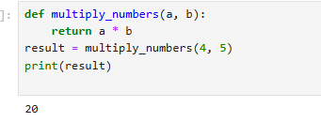

**Task 2:**

Write a function that checks whether a number is even or odd.

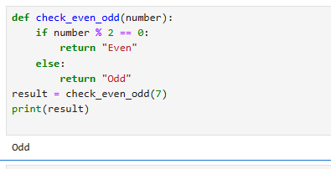

**Task 3:**

Write a function that takes a name and age and prints a greeting**.**

